1. 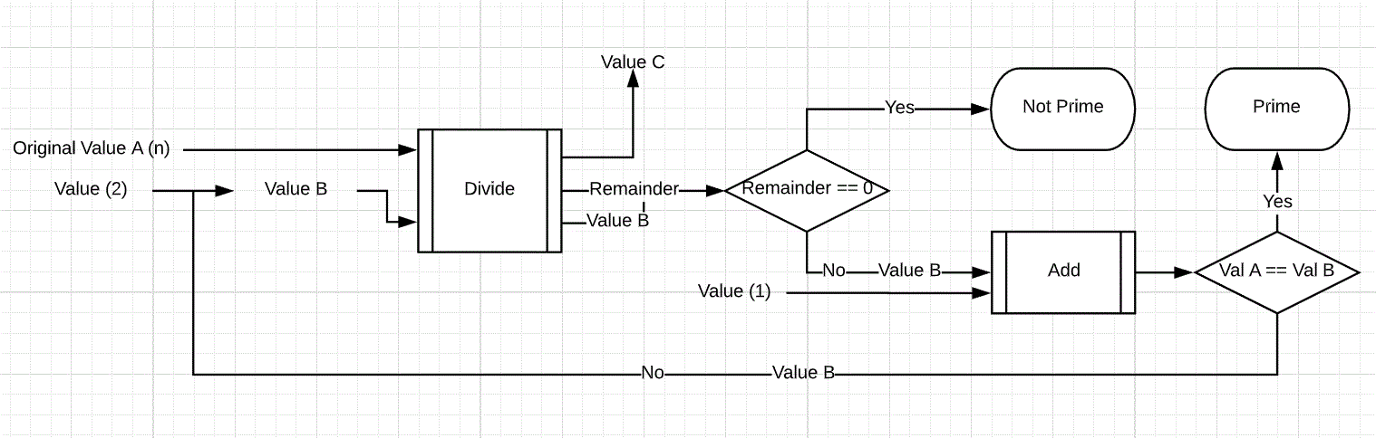
2. Necessary Black Boxes: Division Box, Value Comparer (Remainder), Addition Box, Value Comparer (Values A and B)
3. Define/Declare Value A (n)

Define/Declare Value B (2)

Function Start (Pass Values A and Value B)

Divide (Mod) values A and B  
 Compare Remainder to 0  
 If Remainder equals 0  
 Value isn’t a prime  
 Else Remainder doesn’t equal 0  
 Add 1 to Value B  
 Call Function (Pass Values A and Value B)